**Freezing Point Determination**

**HIGH SCHOOL**

**Green Chemistry & Sustainable Science**

**Teacher Background Information:**

Organic solvents are typically used in this experiment, such as ethylene glycol, 2-methyl-2-propanol or cyclohexane. Unknowns are used, such as naphthalene, p-nitrotoluene, or a similar halogenated aromatic compound. The organic solvents have high flammability and many of the unknowns have high human health hazards associated with them. The greener version of the colligative properties laboratory exercise uses fatty acids to measure the freezing point depression of a fatty acid as an unknown is added. This lesson has been modified to be completed in a 45- min lab period and has eliminated the calculations of using an unknown just focusing on the lab practice and analyzing colligative properties. This experiment is adapted from a Journal of Chemical Education article describing a laboratory experiment for the undergraduate chemistry course (McCarthy, S. M., and Gordon-Wylie, S. W., “A Greener Approach for Measuring Colligative Properties”, J. Chem. Ed., 82 (1), 2005, 116-119).

**Safety Information:** Use care when handling hot plate and beaker with hot water.

**Student Objectives:** Students will…

* Define colligative properties
* Calculate freezing point
* Explain phase change

**Materials:**

* 18 x 150 mm test tube
* 25 x 150 mm test tube
* Paper towels
* Thermometer
* 9 grams stearic acid
* 600 mL beaker
* Test tube stand
* Hot plate
* Water

**Time Required:** 1 x 45 min class

**NGSS Standards Met:**

* **HS-PS1-5.** Apply scientific principles and evidence to provide an explanation about the effects of changing the temperature or concentration of the reacting particles on the rate at which a reaction occurs.
* **HS-PS1-10.** Use evidence to support claims regarding the formation, properties and behaviors of solutions at bulk scales.
* **HS-PS3-4.** Plan and conduct an investigation to provide evidence that the transfer of thermal energy when two components of different temperature are combined within a closed system results in a more uniform energy distribution among the components in the system (second law of thermodynamics).

**Key Terms**: Freezing point determination, kinetic molecular theory, thermodynamics

**Disposal Information:**  The fatty acids can be saved from year to year in a capped test tube.

**Freezing Point Determination Student Lab**

**Pre-lab:**

1. Do colligative properties depend on the number of particles dissolved, the identity of the particles dissolved, or both?

2. Define freezing point

**Materials:**

* 18 x 150 mm test tube
* 25 x 150 mm test tube
* Paper towels
* Thermometer
* 9 grams stearic acid
* 600 mL beaker
* Test tube stand
* Hot plate
* Water

**Procedure:**

1. Prepare an insulating jacket by wrapping a piece of paper towel around an 18 x 150 mm test tube, A, and fitting it in a 25 x 150 mm test tube, B. Remove the 18 x 150 mm test tube, A, and reserve the 25 x 150 mm test tube, B, and the paper towel as the insulating jacket (see Figure A). The insulating jacket prevents premature cooling due to contact with the skin or other surface.

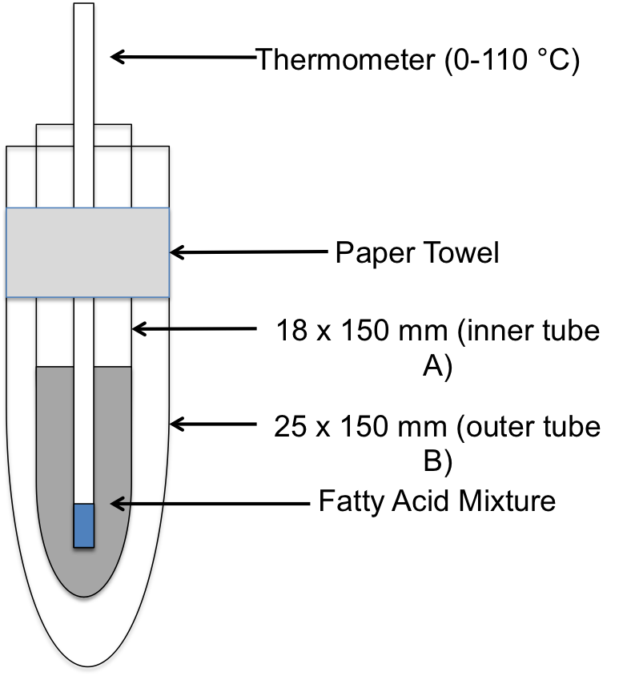

Figure A: Schematic for the construction of an insulating jacket.

1. Measure 9 grams of stearic acid using a balance and add the stearic acid to the 18 x 150 mm test tube.
2. Prepare a hot water bath by filling a 450 ml of a 600 ml beaker with tap water and heating with a hot plate.
3. Immerse the 18 x 150 mm test tube containing the stearic acid sample in the hot water bath to melt the sample. After the sample has completely melted, heat until the sample reaches 85 °C. Leave the thermometer in the test tube for the entire experiment. Remove the test tube from the water and dry the outside.
4. Place the 18 x 150 mm test tube containing the fatty acid sample in the previously prepared insulating jacket. Stirring constantly with the thermometer, record the temperature of the sample every 30 seconds for 8-10 minutes. Temperatures are collected until the temperature of the sample remains constant, changing by less than 0.1 °C per reading, for 3 minutes, 6 readings.
5. Circle the point on your data table where the substance starts to solidify.

Freezing Point Determination /Depression Lab Data:

Temperature data of pure stearic acid:

Starting temperature (Time = 0):_______________ Freezing Point_____________

|  |  |  |  |  |  |
| --- | --- | --- | --- | --- | --- |
| Time | Temp stearic acid | Temp water | Time | Temp stearic acid | Temp water |
| 0.5 min. |  |  | 6.5 min. |  |  |
| 1 min. |  |  | 7 min. |  |  |
| 1.5 min. |  |  | 7.5 min. |  |  |
| 2 min. |  |  | 8 min. |  |  |
| 2.5 min |  |  | 8.5 min. |  |  |
| 3 min. |  |  | 9 min. |  |  |
| 3.5 min. |  |  | 9.5 min. |  |  |
| 4 min. |  |  | 10 min. |  |  |
| 4.5 min. |  |  | 10.5 min. |  |  |
| 5 min. |  |  | 11 min. |  |  |
| 5.5 min. |  |  | 11.5 min. |  |  |
| 6 min. |  |  | 12 min. |  |  |

**Data Analysis**

Use graph paper to make a graph of our data plotting Temperature vs. Time.

**Questions**

1. Why does the temperature of the system decrease over time? Where does the heat energy go?
2. What is the purpose of the insulating jacket?
3. What phase change is occurring during the plateau on the graph?
4. Why does a puddle of water freeze before a lake? Is the freezing point dependent on the volume?
5. Calculate percent error of freezing point of stearic acid. The accepted value is______degrees C.
6. What error or problems surfaced during this lab?