

**MIDDLE SCHOOL**

**Green Chemistry**

**Chemistry with a Conscience:**

**The Science of Shampoo**

Beyond Benign is a non-profit organization working in green chemistry and sustainability through workforce development, trainings and curriculum development in academia, community outreach and K-12 education.

Beyond Benign’s *Chemistry with a Conscience* program is designed to capture the imagination for all students of science. This unit is intended to demonstrate science in the world connections, facilitated by the concepts of sustainability and green chemistry.  Through this unit, all students will see how science relates to their lives in and out of school. For teachers who are striving to facilitate STEM (Science, Technology, Engineering and Math), this unit brings together each of those variables.

With these materials, the goal is to increase awareness of sustainability issues in a non-biased way where hands-on experiences help students investigate the world around them. Students use science skills to solve problems, reach conclusions and come to new understandings; therefore answering the age old question, “Why do I have to know this?” and placing science at the forefront of critical and innovative thinking.

**Acknowledgements**

Thanks to the curriculum development team for this project:

**United States:**

**Greg Sloan**: Terre Haute, Indiana

**Brenda Thompson-Leffler:**  Frisco, Colorado

**Amy Treese:** Glenwood Springs, Colorado

**Canada:**

**Matthew MacGregor:**  London, Ontario

**Australia:**

**Helen Conidaris:** Merrickville, New South Wales

**Janelle Forrest:** Sydney, New South Wales

**Tanya Mans:**Wollongong, New South Wales

**Danielle Nash:**Sydney Olympic Center, Sydney, New South Wales

**Beyond Benign Staff:**

**Brooke Carson:** Montezuma, Colorado

**Rachel Pokrandt:** Glenwood Springs, Colorado

Special thanks for their help with this project go to:

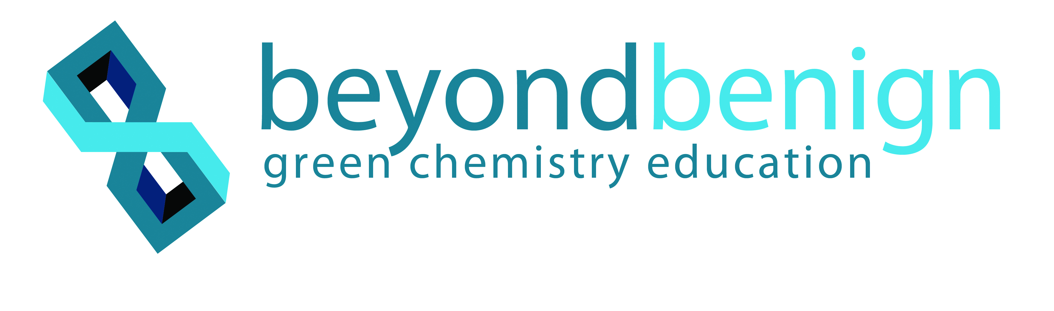**Marge Anderson,** former Pfizer liaison

**Amy Cannon,** Beyond Benign

**John Warner,** Warner Babcock Institute for Green Chemistry

**The Twelve Principles of Green Chemistry**

John Warner and Paul Anastas have developed the Twelve Principles of Green Chemistry to aid in assessing how green a chemical, reaction or a process is.

1. It is better to prevent waste than to treat or clean up waste after it is formed.

2. Synthetic methods should be designed to maximize the incorporation of all materials used in the process into the final product.

3. Wherever practicable, synthetic methodologies should be designed to use and generate substances that possess little or no toxicity to human health and the environment.

4. Chemical products should be designed to preserve efficacy of function while reducing toxicity.

5. The use of auxiliary substances (e.g. solvents, separation agents, etc.) should be made unnecessary whenever possible and, innocuous when used.

6. Energy requirements should be recognized for their environmental and economic impacts and should be minimized.  Synthetic methods should be conducted at ambient temperature and pressure.

7. A raw material feedstock should be renewable rather than depleting whenever technically and economically practical.

8. Unnecessary derivatization (blocking group protection/deprotection, temporary modification of physical/chemical processes) should be avoided whenever possible.

9. Catalytic reagents (as selective as possible) are superior to stoichiometric reagents.

10. Chemical products should be designed so that at the end of their function they do not persist in the environment and break down into innocuous degradation products.

11. Analytical methodologies need to be further developed to allow for real-time in-process monitoring and control prior to the formation of hazardous substances.

12. Substances and the form of a substance used in a chemical process should be chosen so as to minimize the potential for chemical accidents, including releases, explosions, and fires.

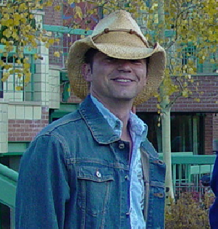**Staff**

**Greg Sloan** has been teaching middle school science in Terre Haute, IN since 1992. He holds a Bachelor's Degree in Education from Indiana University and a Master's Degree in Administration and Supervision from Indiana State University. Greg has developed and facilitated basic math and science courses for the employees of the Pfizer plant in Terre Haute. He has worked on developing hands on activities to address the Indiana State Standards for the State of Indiana. Greg has also facilitated workshops in his district in order to help elementary teachers implement more science into the curriculum and has had activities published by Prentice Hall in the supplemental booklet; "Student - Centered Science Activities for the Midwest". Greg grew up in the hills of the Ohio River Valley in Southeastern Indiana and is the proud father of two boys who keep him very busy.

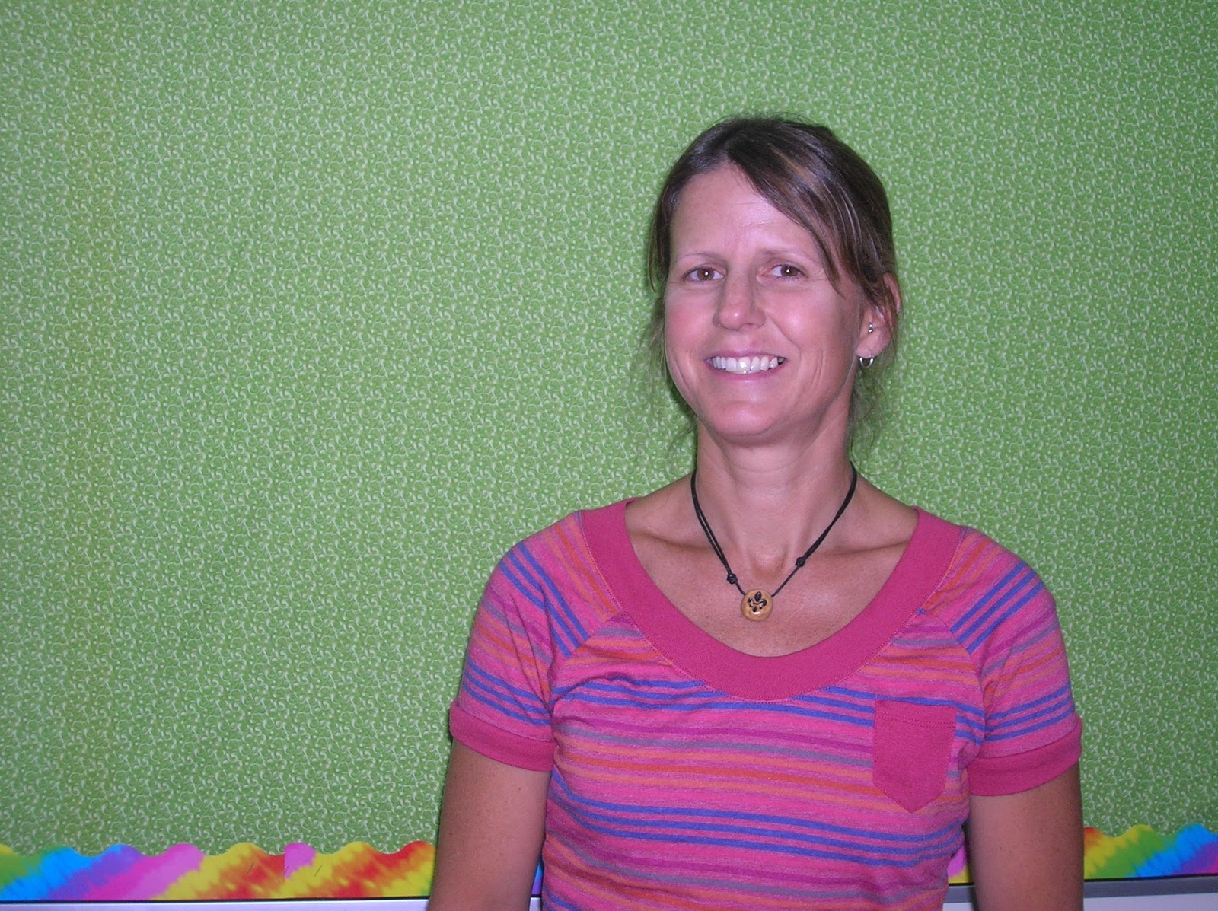**Brenda Thompson-Leffler** began her middle school teaching career in 1993 and is currently working at Summit Middle School in Frisco, Colorado.  Her focus has been on 6th and 7th grade science.  She has run semester long green chemistry courses for 6th graders and has been an integral part of the curriculum development team since the inception of the project.  She also teaches a green biotechnology course for 7th grade students, bringing the 12 Principles of Green Chemistry to different disciplines within science. Brenda earned her B.S. and M.A. in Education. More importantly, she is the proud mom of her baby girl, Darby. As a resident of Breckenridge, Colorado, Brenda spends her spare time telemark skiing and trail running. Brenda grew up in Louisiana and loves to visit her large family back in LA, but admits she is now a "mountain girl."

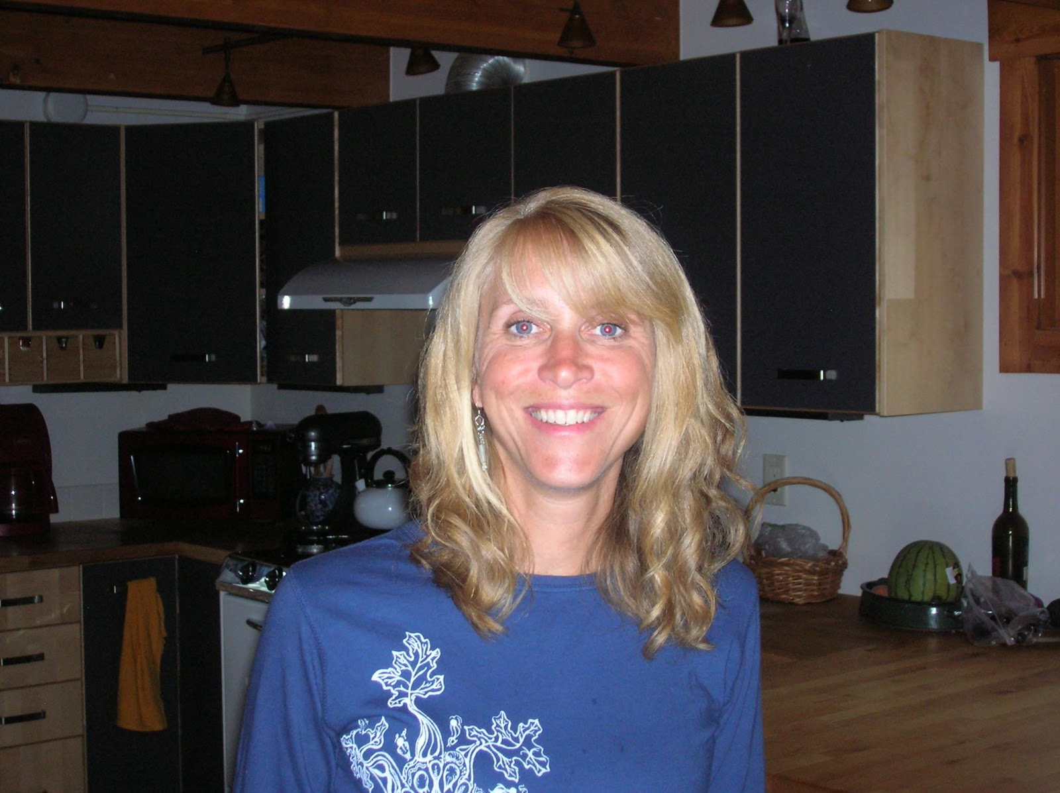 **Brooke CARSON** joined the Beyond Benign team as the Co-Director of K-12 Curriculum and Training in July of 2009.  Prior to this role, she was a middle school teacher for 8 years in the state of Colorado, specializing in differentiated instruction and integration of cross-disciplinary units.  Brooke previously served as the Director of Teacher Training at The Keystone Center in Keystone, Colorado for 8 years; by instituting programs with government agencies such as NASA, The Department of Energy and corporations such as, SC Johnson Wax and Pfizer, she had the opportunity to grow the professional development division from one yearly institute to eight curriculum projects.  She has presented sustainability concepts to corporate audiences locally and internationally.  The bulk of her experience rests with local, national, and international teacher training, and she continues to focus on providing professional development experiences for educators.  Living with her husband in a small town in Colorado at 10, 400 feet, Brooke predictably loves being in the outdoors.

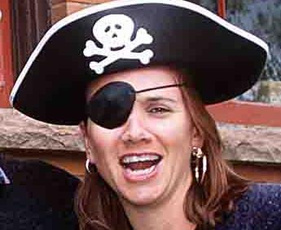**Rachel Pokrandt** is the Co-Director of K -12 Curriculum and Training at Beyond Benign. Rachel has been developing multi-disciplinary sustainable science curriculum for middle and high school students for 5 years, working on programs with Pfizer, The U.S. Department of Energy, NASA, DuPont and DOW Chemical. Rachel has been involved in Green Chemistry Education through the ‘Recipe for Sustainable Science’ and ‘Solutions in Green Chemistry’ programs of Beyond Benign and has trained over 340 teachers in the use of these materials through summer institutes and weekend workshops in the U.S., Ireland, England and Puerto Rico. Prior to her curriculum development work, Rachel was a classroom teacher for 7 years.  While Rachel grew up in the United Kingdom, she is now living in Glenwood Springs, Colorado with her husband, daughter, and two dogs.

**Chemistry with a Conscience Lesson Sequence**

|  |  |  |
| --- | --- | --- |
| **Lesson number** | **Lesson Name** | **Lesson Description** |
| 01 | Writing the Principles | Lab activity.  Students create glue and evaluate the process to deduce the 12 Principles of Green Chemistry. |
| 02 | 12 Principle Match Up | Students manipulate simplified versions of the 12 Principles and make real life connections to understand the 12 Principles of Green Chemistry. |
| 02.1 | Bingo with Greg | In this reinforcement activity, students play Bingo to strengthen their understanding of the definitions and life connections associated with each Principle. |
| 03 | *The Story of Cosmetics* Assessment | Using the video, The Story of Cosmetics, students analyze fact, opinion, & bias.  They also are inspired to become more informed consumers. |
| 04 | Is It Easy Being Green | Introduction to students’ green chemistry challenge. |
| 05 | Cookie Equations | Students use cookies to help them understand that chemical equations must be balanced.  They manipulate elements and form compounds represented by cookie parts. |
| 06 | The Heat Is On | Lab activity.  While using sodium hydroxide to create the base of their shampoos, students observe an exothermic reaction, measure the amount of heat, create a temperature over time graph showing their results, and determine ambient temperature strategies to use in the lab |
| 07 | pH Neutral | Lab activity.  Students observe, measure, and record what happens as varying amounts of an acidic solution is added to a basic solution to obtain neutralization. The goal is to create a pH balanced shampoo. |
| 08 | Orb-It | Using GoodGuide.com as a basis for data, students use a graphic organizer, the orb, to make determine which shampoo is the “greenest”. |
| 09 | Solvent Snapshot | Using International Safety cards, students analyze the toxicity of a variety of solvents they could use in the shampoo making process |
| 10 | Shampoozled | Lab activity.  Students create a basic soap.  During this process, they must monitor and maintain a set temperature range. |
| 11 | Shampoozled 2 | Lab activity.  Reviewing the pH Neutral lesson, students strive to create a pH balanced shampoo and experiment with green emulsifiers. |
| 12 | In A Lather | Lab activity.  Students test different variables to see if they impact the effectiveness of the shampoo.  And, they answer the question, “Does the lather matter?” |
| 13 | SLS Today | After viewing a Today Show segment, students evaluate the safety of sodium lauryl sulfate in their shampoos & complete a toxicity analysis. |
| 13.1 | PPM | In this optional lab activity from VWR Education, students practice standard serial dilution to better understand parts per million. |
| 14 | SLS Toxicology | Lab activity.  Students use lettuce or radish seeds to determine the toxicology of sodium lauryl sulfate. |
| 15 | Breaking the Tension | Lab activity.  Students observe the effect of surface tension in water, and the dispersive force of detergents to understand how shampoos work. |
| 16 | Product Test | Lab activity.  Students conduct and experiment to determine if the shampoo they created is effective in cleaning hair. |
| 17 | E-factor | In this activity from Irv Levy, students manipulate m&ms to calculate e-factor and relate it to chemistry production. |
| 18 | In Your Bathroom | Students collect data on ingredients found in products brought from home and investigate the substances used to make these products.  They use this data to practice choosing data display methods. |
| 19 | Puzzler | Students create puzzles analyzing their research on renewable and non-renewable packaging materials. |
| 20 | Packed Up Properties | Lab activity.  Students use the properties of matter & the 12 Principles of Green chemistry to test various packaging materials and determine the most green & effective choice for their shampoo. |
| 21 | Water Waste | Lab activity.  Students test various waste streams likely to come from household products and evaluate the environmental impacts of those wastes. |
| 22 | The Green Zine | Culminating activity.  Students create a magazine test, Goodguide.com web page, and an art campaign to analyze their use of the 12 Principles of Green Chemistry and to promote their implementation. |